Individual Project showcase

## James Thomas 9195071

Cyber Nova – Web vulnerability Scanning Tool

The goal of this project was to create a tool that anyone that owns a computer could use to find out how vulnerable they are on the websites they use. Throughout the project this goal changed form and function a few times, initially the idea was to just check for single vulnerabilities, then we explored the possibility of using the tool as an offensive tool, ultimately taking parts of each idea and creating our final product.

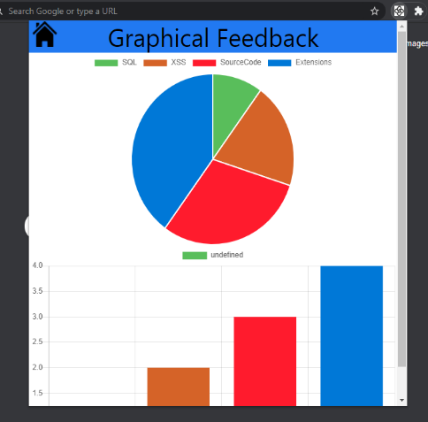In its final form our product would be a browser extension that communicates with a webserver that utilises botkit to run external scripts. In our implementation the extension sends the URL of the currently active page on the user’s browser, sends it to the botkit server which makes a report that’s sent back and displayed for the user to see and act on.

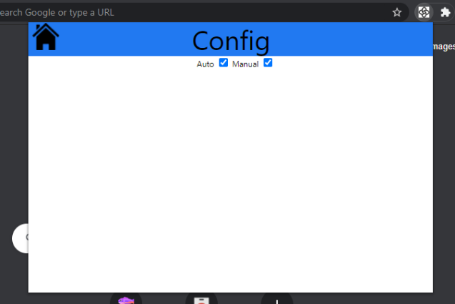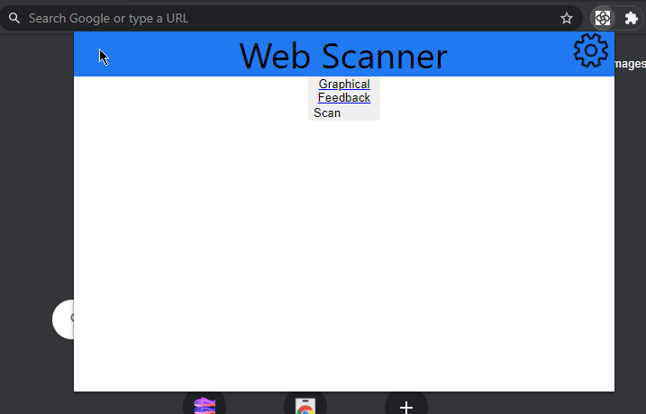

For the final prototype we made 3 prototypes of different areas of the project, the visual UI elements are in the extension prototype pictured above, the user experience prototype is in the form of a PowerPoint that can be operated by potential users and a technical prototype with minimal UI but will perform scans that we planned for the final product.

We hoped to combine these prototypes into a final product but due to time and technical issues we had to leave it at three separate prototypes, each demonstrating a separate part of the product.

By creating this many prototypes and distributing the work throughout the group enabled us to achieve a high standard in each part. If we had decided to struggle against the time and create a single prototype, I believe the standard would have been much lower.

My contribution:

At the start of the project I worked closely with Alexander to try and organise the team, coming up with templates for meetings, scheduling and facilitating them when we met with other members too. Doing this helped me develop leadership skills, observing Alex in meetings and how he organised the documentation also provided me with ample opportunity to learn.

During the project’s initial stages, we all worked in tandem on the parts of the sprint process, with individual tasks being administered occasionally. I personally found this slower pace harder to deal with but when each day got completed it started to click more and we found our rhythm as a team.

During the prototype design, I was tasked with creating the User experience and User interface prototypes. The experience prototype was easy to create using tools I was already comfortable with, so I completed it and started to create the interface prototype to improve our submission. As it was created as a chrome extension, I had to learn many new skills utilising HTML, CSS and JavaScript to get a working example. Initially I wanted to use the Google Charts API to populate our graphical feedback section but that involved using inline scripts in an HTML file, something which is not allowed under the content security policy of chrome extensions. I found a JavaScript library that provided almost identical functionality and used that to create the charts instead. The prototype development had given me a boost in my web design skills and my ability to understand website documents and error codes.

As I was responsible for the two prototypes surrounding what the user interacts with, I did some research into User Interfaces. Factors like colour changing the mood of the customer, fonts being serif or sans-serif and this impacting people with dyslexia or other reading problems or finally the language that is used should be clear and unambiguous. Tailoring the product to the target audience that was set early on in the project was another large issue to tackle in the prototypes, the product had to look professional and stylish while also being simple enough for the less technologically minded to be able to use with ease.

Post-mortem:

Overall, I think the project was a success, we created what we set out to create. It was a struggle at first with the way we must learn during the Covid pandemic, online meetings were new to all of us and as the project progressed it was harder to get everyone to join at the same time. This resulted in sometimes work being done that wasn’t in line with the project or work that was meant to be done was handed in late or incomplete. Due to efforts from myself and Alex these issues were not a factor in the end.

The sprint process overall seems like a functional system but is not at all suited to this style of online learning we use now. Having a process that is specifically designed to be completed over a single week spread out over many months does not make sense at all and is counterproductive. At times we as a group started to work in a more natural agile way, resulting in progress on the project goal but then missing sprint documents essential to the group submission. To resolve this we created our own easier to understand checklists making sure we had all the relevant documentation for each day of the sprint process, the regular meetings on a Monday and Friday helped us a lot with tackling this issue.

A method I came up with to help us follow the sprint process more closely was to take out the sprint book from the library and in each meeting I would sit with the book and offer solutions straight from the book when people had a query, eliminating the guess work and speculation that was causing a lot of our problems in the beginning.

The use of botkit in the project was very confusing and we did not know how much of the project had to be focused around it. If this was more clearly explained I think our group could have focused on the important issues at a much earlier date.